Name ___________________
Scientific Method Extra Credit

Period __________________

Pick ONE of the following stories and answer the questions about the scientific method.
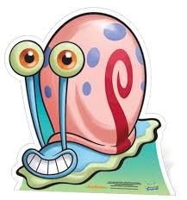
Slimotosis
SpongeBob notices that Gary and some of his friends are suffering from slimotosis, which occurs when the shell develops a nasty slime and gives off a horrible odor. His friend Patrick tells him that rubbing seaweed on the shell is the perfect cure, while Sandy says that drinking Dr. Kelp will be a better cure. Sponge Bob decides to test these cures. SpongeBob makes Gary drink Dr. Kelp for one week. He rubs Gary’s friend Snellie with seaweed for 1 week. He doesn’t give Gary’s other friend, Lightning Luciano any treatment for slimotosis. At the end of 1 week, SpongeBob observes all three snails. He notices that Gary’s slimotosis doesn’t smell so bad, but that he is still covered in slime. Snellie has almost no slime on his shell and doesn’t smell at all. Lighting Luciano is covered with smelly slime and has to stay outside so the others don’t throw up!
- What is the problem? What does SpongeBob want to know?
_____________________________________________________________________________________
- What is SpongeBob’s hypothesis?
______________________________________________________________________________________
- Describe SpongeBob’s experiment.
______________________________________________________________________________________
______________________________________________________________________________________
______________________________________________________________________________________
- What is the control in the experiment?
______________________________________________________________________________________
- What is the independent variable in the experiment?
______________________________________________________________________________________
- What is the dependent variable in the experiment?
______________________________________________________________________________________

- What should SpongeBob’s conclusion be?
______________________________________________________________________________________
- How do you think SpongeBob can communicate the results of his experiment?
______________________________________________________________________________________
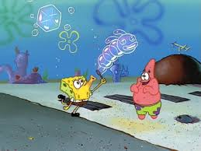
Super Bubbles
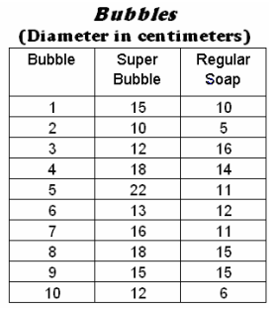
Patrick and SpongeBob love to blow bubbles! Patrick found some Super Bubble Soap at Sail-Mart. The ads claim that Super Bubble Soap will produce bubbles that are twice as big as bubbles made with regular bubble soap. Patrick and SpongeBob made up two samples of bubble solution. One sample was made with 5 oz. of Super Bubble Soap and 5 oz. of water, while the other was made with the same amount of water and 5 oz. of regular bubble soap. Patrick and SpongeBob used their favorite bubble wands to blow 10 different bubbles and did their best to measure the diameter of each one. The results are shown in the chart:

- What is the problem? What do SpongeBob & Patrick want to know?
____________________________________________________________
- What is SpongeBob’s hypothesis?
____________________________________________________________
- Describe SpongeBob’s experiment.
___________________________________________________________
______________________________________________________________________________________
______________________________________________________________________________________
- What is the control in the experiment?
______________________________________________________________________________________
- What is the independent variable in the experiment?
______________________________________________________________________________________
- What is the dependent variable in the experiment?
______________________________________________________________________________________
15. Look at the results in the chart.
a. Calculate the average diameter for each bubble solution. (Add up all of the numbers and divide by how many numbers you added together. You can use a calculator.)

Super Bubble = ______ cm Regular Soap = ________ cm

b. What should their conclusion be?
______________________________________________________________________________________
- How do you think SpongeBob & Patrick can communicate the results of his experiment?
______________________________________________________________________________________

